

press release
(English translation)

IEG: AT MIR 2023 THE backstage IS on stage
THANKS TO THE EXCLUSIVE FORMAT “live you play”
From April 2nd to 4th 2023, the most awaited event by professionals and live entertainment enthusiasts returns to the Rimini Expo Centre. Robotic stages, listening rooms for immersive audio and audio comparison systems represent an unmissable opportunity to experiment with new technologies and innovative solutions dedicated to events and live entertainment

- Thanks to the partnership with "Live You Play", two perfectly equipped stages will be set up to see the most innovative live entertainment equipment in action
- Immersive Rooms: three demo rooms to experience immersive sound
- The “Contest Colonne” project will allow perfect comparative listening to systems

www.mirtechexpo.com
Rimini, 29 March 2023 – Once again this year MIR, an unmissable event for all live entertainment professionals and enthusiasts, brings the backstage on stage thanks to the now consolidated partnership with Live You Play. The demo areas therefore promise to be among the most interesting and engaging within the pavilions of the Rimini Expo Centre where, from April 2nd to 4th, the VI edition of the event organized by the Italian Exhibition Group will take place.
Center of gravity will be the two stages equipped with the best technologies and systems that will allow you to see in action, thanks to real live shows, the audio, video and lighting solutions proposed by some of the sector's leading companies. It is an unmissable opportunity, as well as a unique format in the world, dedicated to all professionals to evaluate the strengths of new equipment in their context of use par excellence: the stage.
More specifically, the special “Live System Contest” stage will be set up in pavilion C1. Here it will be possible to listen to five audio systems - set in rotation thanks to a robotic pointing system, to make them all play in the same position - in a listening comparison not spoiled by the different positioning of the systems. Another great novelty of this year is the "Contest Mixer", set up on the stage of pavilion C3 and created to give the possibility of a comparative listening of five audio mixers with a single reference Point Source audio system. You will be able to access the consoles during the mixing phase.
Visitors will be assisted by the companies' technicians and product managers who will guide them in discovering all the devices and new technologies implemented on the stages.
That's not all, of course. Building on the success of the last edition, MIR cannot miss the IMMERSIVE ROOMS, a soundstage area that develops into three demo rooms to experience immersive sound. The rooms will host the solutions and projects of YAMAHA and NEXO with AFC, WHARFDALE PRO and AUDIOLINK with TIMAX 2 and L'ACOUSTIC with L'ISA, among the few companies in the world to offer this type of system.
Another important pole of attraction is certainly the SOUND ARENA (SOUTH hall), where for the second consecutive year the “Contest Colonne” project will come to life, dedicated to systems with vertical development on stands or columns of different sizes. The special set-up is designed for high-quality comparative listening, thanks to the possibility of listening to all the systems at the same distance. Finally, some maxi LedWalls will project the characteristics and specifications of each device to allow a perfect understanding of all the peculiarities of the products.
MIR 2023 AT A GLANCE
Organisation: Italian Exhibition Group SpA; Recurrence: annual; Edition: 6th; Open to: professional operators and general public; website: www.mirtechexpo.com

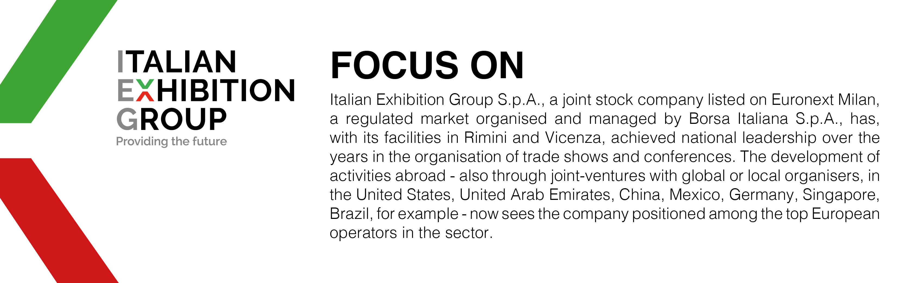

PRESS CONTACT ITALIAN EXHIBITION GROUP
Head of media relations & corporate communication: Elisabetta Vitali
Press office manager: Marco Forcellini

MEDIA AGENCY MIR
Naper Multimedia| Zoe Perna | T. +39 02 97699600 | email: staff@napermultimedia.it

This press release contains forecast elements and estimates that reflect the management’s current opinions (“forward-looking statements”), particularly regarding future management performance, realization of investments, cash flow trends and the evolution of the financial structure. For their very nature, forward-looking statements have a component of risk and uncertainty, as they depend on the occurrence of future events. The effective results may differ (even significantly) from those announced, due to numerous factors, including, only by way of example: food service market and tourist flow trends in Italy, gold and jewellery market trends, green economy market trends; the evolution of raw material prices; general macroeconomic conditions; geopolitical factors and evolutions in the legislative framework. Moreover, the information contained in this release does not claim to be complete, and has not been verified by independent third parties. Forecasts, estimates and objectives contained herein are based on the information available to the Company as at the date of this release.

